Introduction

Brief explanation of EPROMs

Purpose of reading and writing BIN files

Prerequisites

List of required tools and materials:

* EPROM Programmer
* UV Eraser (If using UV Erase EPROM)
* Adapters for Programmer if needed
* Computer with necessary software
* BIN file
* EPROM

**Note:** for this guide we will be using a “CGecu Pro T48 USB Programmer”, these can be found on eBay and AliExpress for about AUD $70, if you are purchasing one for programming Memcals, be aware that there are plenty of counterfeit ones that will not support the high programming voltages of the 27C series EPROMS.

Section 1: Reading BIN Files from EPROMs

Step 1: Setting Up

Connect the EPROM programmer to your computer

Install necessary software and drivers

Step 2: Preparing the EPROM

Remove the EPROM chip from the device

Place the EPROM chip in the programmer socket, ensuring correct orientation

Prerequsite Setup:

This section will guide you through setting up the “XGecu T48”

Download the latest software from the manufacturers website

<http://www.xgecu.com/EN/download.html>

This software is packaged in a .rar archive, so you will need an application like WinRAR to extract it, (Microsoft is releasing .RAR support in a Windows Update in the near future)

XGpro Software Installation

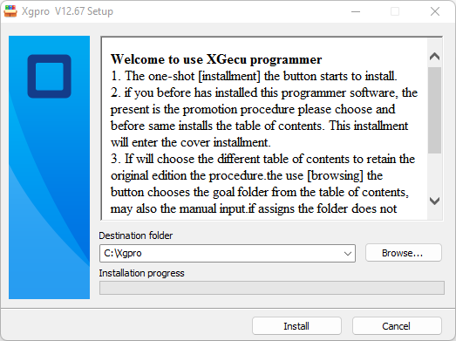

Once this step complets, it wil install the drivers for the programmer

Preparing the BIN file

What is Bin Stacking

EPROM bin stacking is a technique used when you want or need to use a larger EPROM (like a 256k EPROM) to replace a smaller one (like a 128k EPROM) in the same physical package.

Bin Stacking Process:

Divide the Larger EPROM into Sections: Think of the 256k EPROM as two separate 128k sections stacked on top of each other.

Stacking the Bins: You "stack" the data for the 128k EPROM into one 128k section of the 256k EPROM. The remaining 128k section of the 256k EPROM can either be left empty or 2 copies of the Bin can be written in that space (there are mods that will allow you to run 2 different bins and switch between them).

Also Note, generally the 256/512K EPROM references are in *Kilobits* and the BIN sizes are in *Kilobytes*,

Therefore a 16K BIN file is full capacity of a 128K EPROM



Visual Representation of Bin Stacking